**HPCS**

**LAB 1 WEEK 1**

**OpenMP PROGRAMMING**

1. Write an OpenMP program to use variables as shared or private

Code:

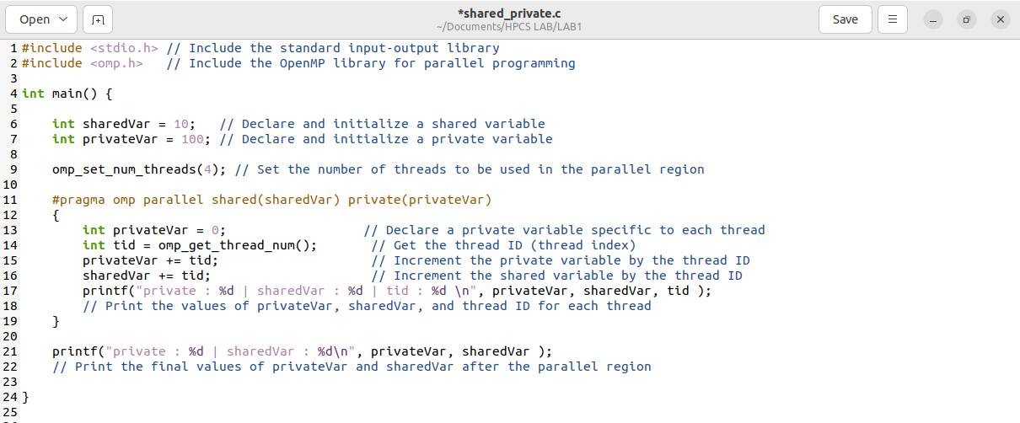

Results:

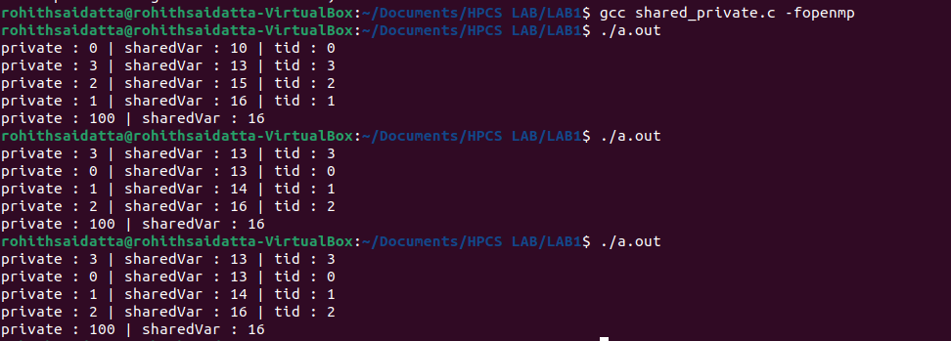

2 Write an OpenMP program to sum the respective elements of the two arrays

1. using a number of threads equal to the number of CPU cores.

Code:

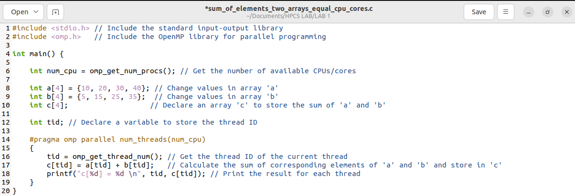

Results:

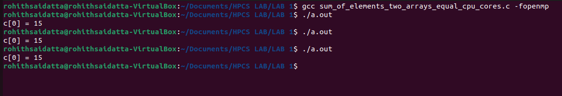

1. using number of threads irrespective of number of CPU cores

Code:

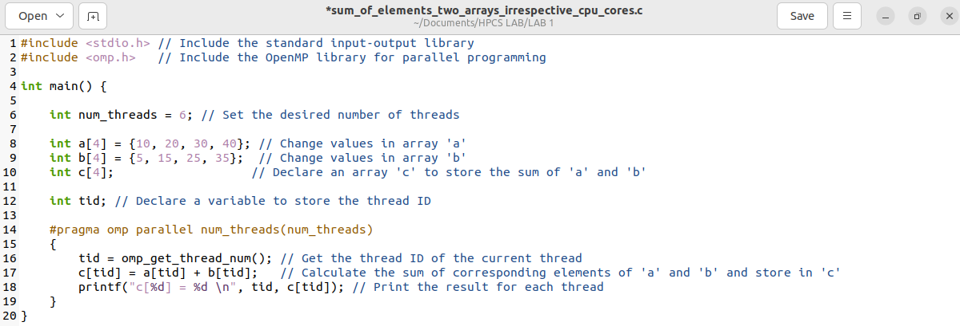

Results:

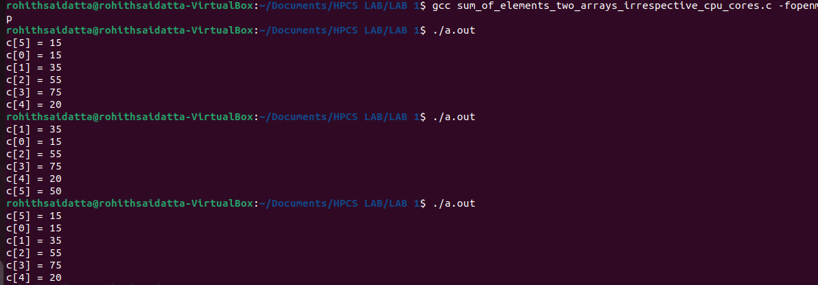

1. Write an OpenMP program to find the sum of integers from 1 to N
2. using parallel for loop

Code:

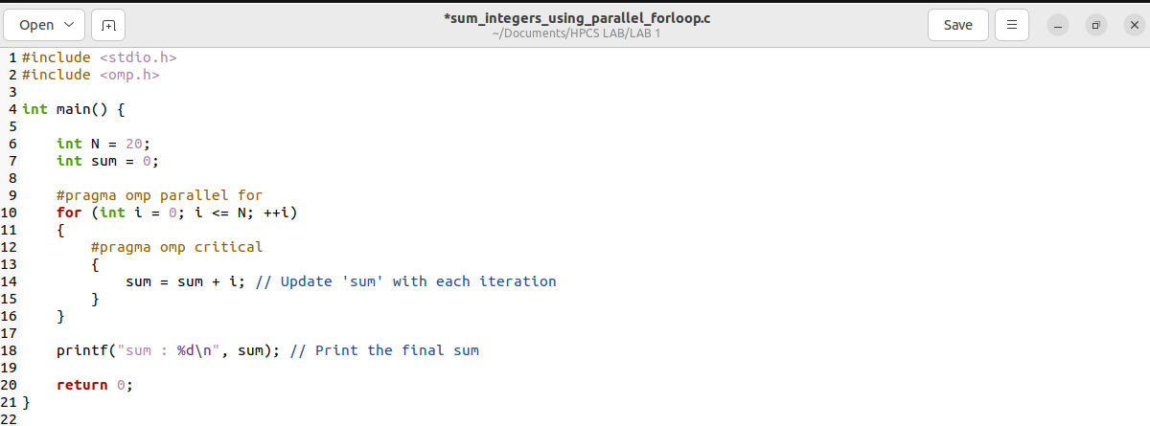

Results:



1. using reduction clause in parallel for loop

Code:

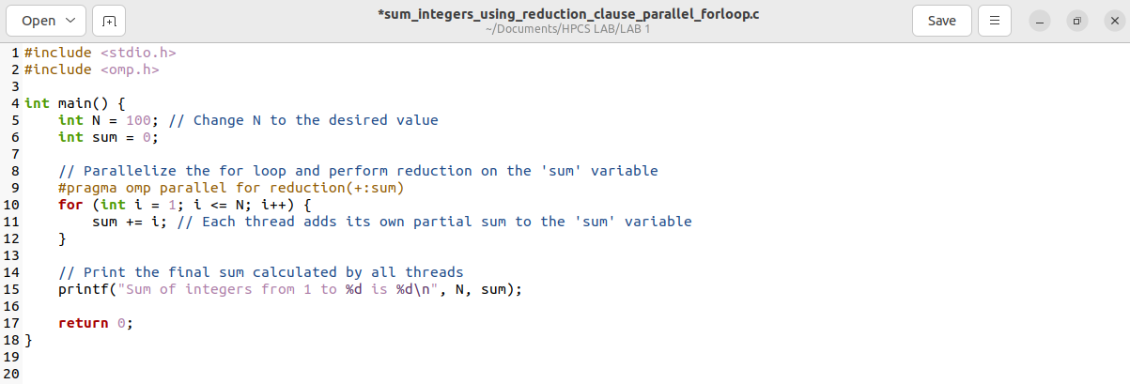

Results:



4. Write an OpenMP program to parallelize nested for loop for any program

Code:

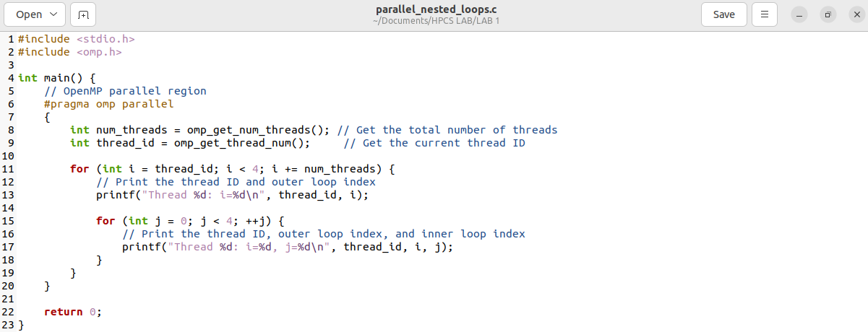

Result: